**Letter Soup**

***Crypto***

**Challenge:**

We believe we have ran into one of the newest members of DEADFACE while they were waiting for the train. The member seemed to have gotten spooked and stood up suddenly to jump on the train right before the doors shut. They seemed to have gotten away, but dropped this innocent looking word search. I believe this member might be actually a courier for DEADFACE. Let’s solve the word search to decode the mystery message. We believe the message might tell us their next move.

Submit the flag as flag{TARGETNAME} (e.g., flag{THISISTHEANSWER})

Attached - Deadface_Word_Search.png

**Approach:**

The png file is a simple word search they gave us, upon finding all the words in the word search we were left with a bunch load of letters.

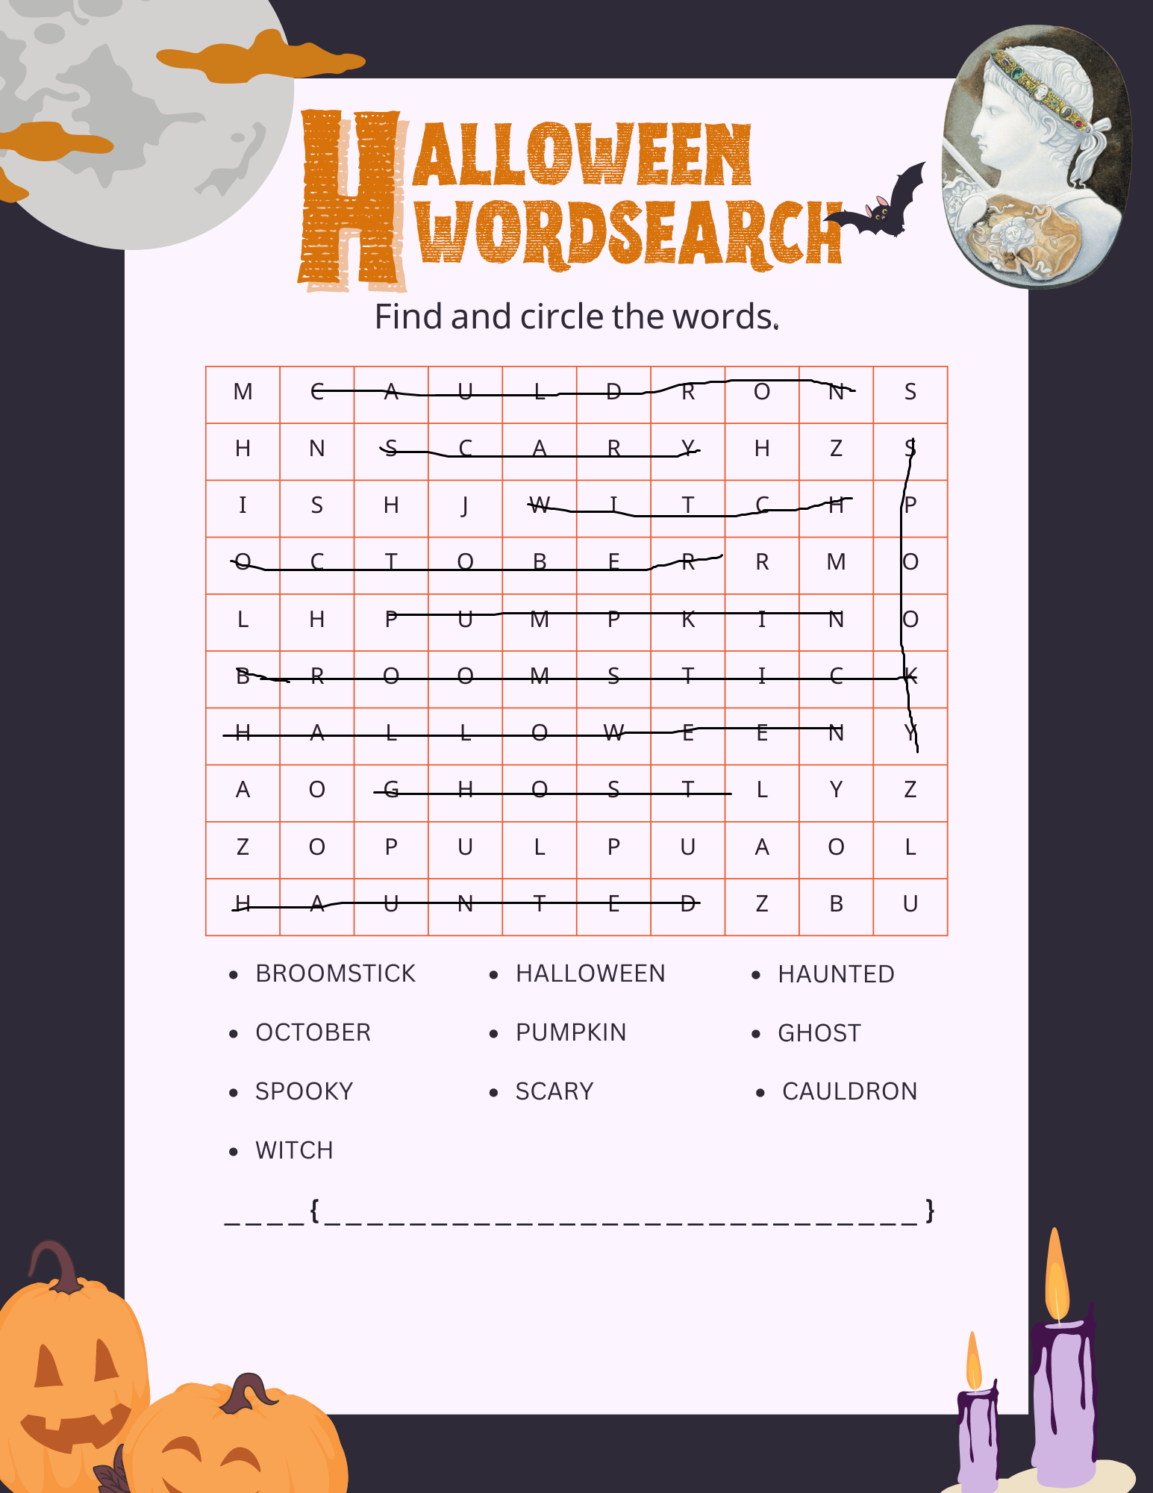

We combine all those letters into one word and get:

MSHNHZISHJRMLHAOLYZZOPULPUAOLZBU

We put this on caesar cipher decoder and get this on Right shift 7:

FLAGASBLACKFEATHERSSHINEINTHESUN

Hence our flag

**Flag: flag{ASBLACKFEATHERSSHINEINTHESUN}**

Congrats!!

Happy Hacking!